**USEFUL SCREENSHOTS TO AID NAVIGATION OF SPYDER**

Once Spyder is opened you should see this interface:

Help viewer

Run command icon.

Fig.1 Spyder Interface

Console

Editor

Open script icon

Click the open script icon to open your preferred ABM file and load it. Select abm9 to see the final output. Make sure to select and open all files in the folder. Then click the run button to run the script.

This produces a GUI interface as seen below:

Click run model to start simulation.

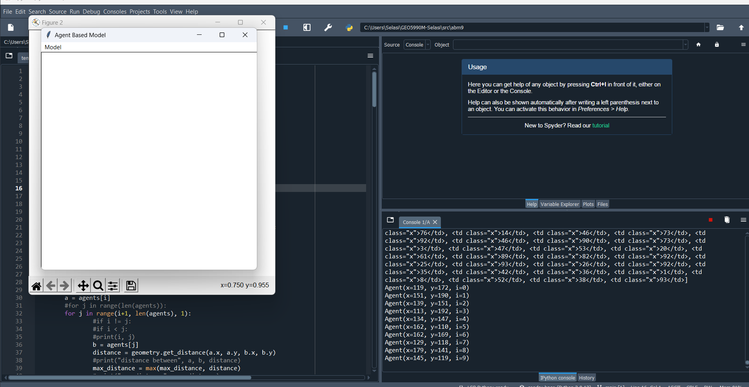

Fig2. ABM model simulation view

After clicking, model, a new drop-down menu appears. Select run model to start simulation

Fig3. Instruction to run model

This produces this interface with the simulation running.

Fig.4 Simulation running

To solve errors caused by wrong file paths in python manager, click python manager icon and click add file path from the popup window. Add the appropriate file path and run the code again.

Python manager button

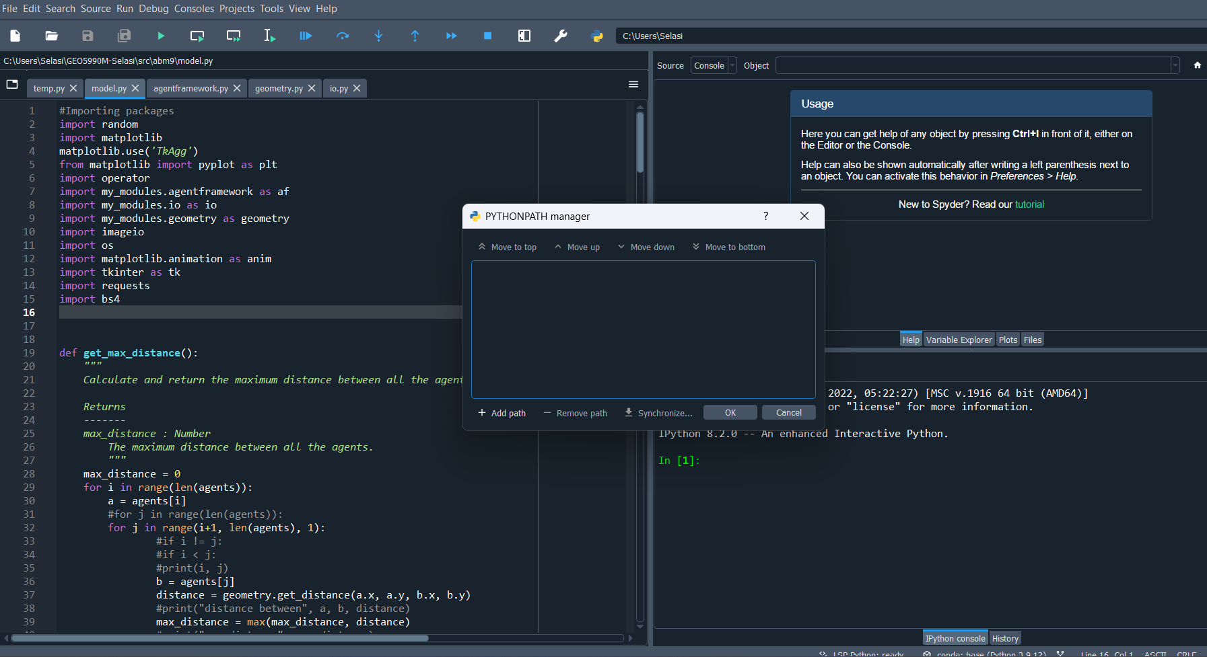

Click to add file path

Fig.5 Adding file path to fix error.